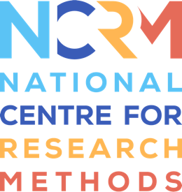
Generative AI Tools for Quantitative Research

Video 2 transcript

Video: https://youtu.be/OQ1-5s7biKA

David Bann: In this second video, we’ll be showing you how to use large language models within your code interpreters, so within your IDEs. We’ll be using LLMs to edit R scripts in VS code using GitHub Copilot. And we’ll be using two different LLMs to conduct these tasks. We’ll first use large language models via a cloud provider, where your data is sent across the internet to the GPT 4.1 model. And then we’ll be using Copilot via a local large language model, in which our data is not sent over the internet, using the Ollama application and the Gemma series of large language models.
Here we are within the VS code application. We have opened up the GitHub Copilot window, and we’ve selected some code – we want to change the colour from red into blue. So we can request that in plain language. The large language model is then working in the background. Because this is a cloud-based model, it’s sending data across the internet. It makes a code suggestion, which we can keep if we’re happy with it, and our code is then amended.
And here we are changing the large language model we’re using within VS code. We’re going to click ‘Ollama’, and we have an option of all the different large language models which we have downloaded for us to use locally. Then we can select which model we want to use. We selected the Gemma model, and we can request code suggestions or code changes, just as we did before using the cloud-based model. So here we will request R code to make a histogram.
And we can see that credible-looking code is appearing on the right, which we can then insert into our code base if we are happy with it.

National Centre for Research Methods (NCRM)
Social Sciences
Murray Building (Bldg 58)
University of Southampton
Southampton SO17 1BJ
United Kingdom
Web www.ncrm.ac.uk
Email info@ncrm.ac.uk
Tel +44 23 8059 4539
Twitter @NCRMUK

